- Introduction.
- Automatic Test.
  - Test DAC
  - Test Voltage.
  - Test Adder Channels.
  - Test Analog Offset.
  - Test Digital Offset.

- Fitting Rate scan result.
  - Method.
  - Offset calculation for all ASICs.
  - Gain calculation for all ASICs.

- Difference Analog and Fit Offset.
- Noise.

- Fitting Rate scan Result.

  - Method.

During the automatic voltage test it has been measured the output rate scan result voltage for all channels, adders and discriminators of each of the ASICs analyzed.

From the relation between the input signal given to the circuit and the rate scan result it must be possible to retrieve information such as the offset and the gain of the ASICs. If this method is accurate, the offset calcularted must be similar to that measured directly in the analog offset test.

We must assume that at certain range of voltage there is a linear dependence between the input signal and the ratescan result, being:

(1) Vrs = Gain * Vin + Offset

Ratescan voltage versus input voltage was plotted for all channels, adders and discriminators of ASIC 61 in order to analyze the linear range of the relation and decide which range would be the better to compute the offset and gain values.

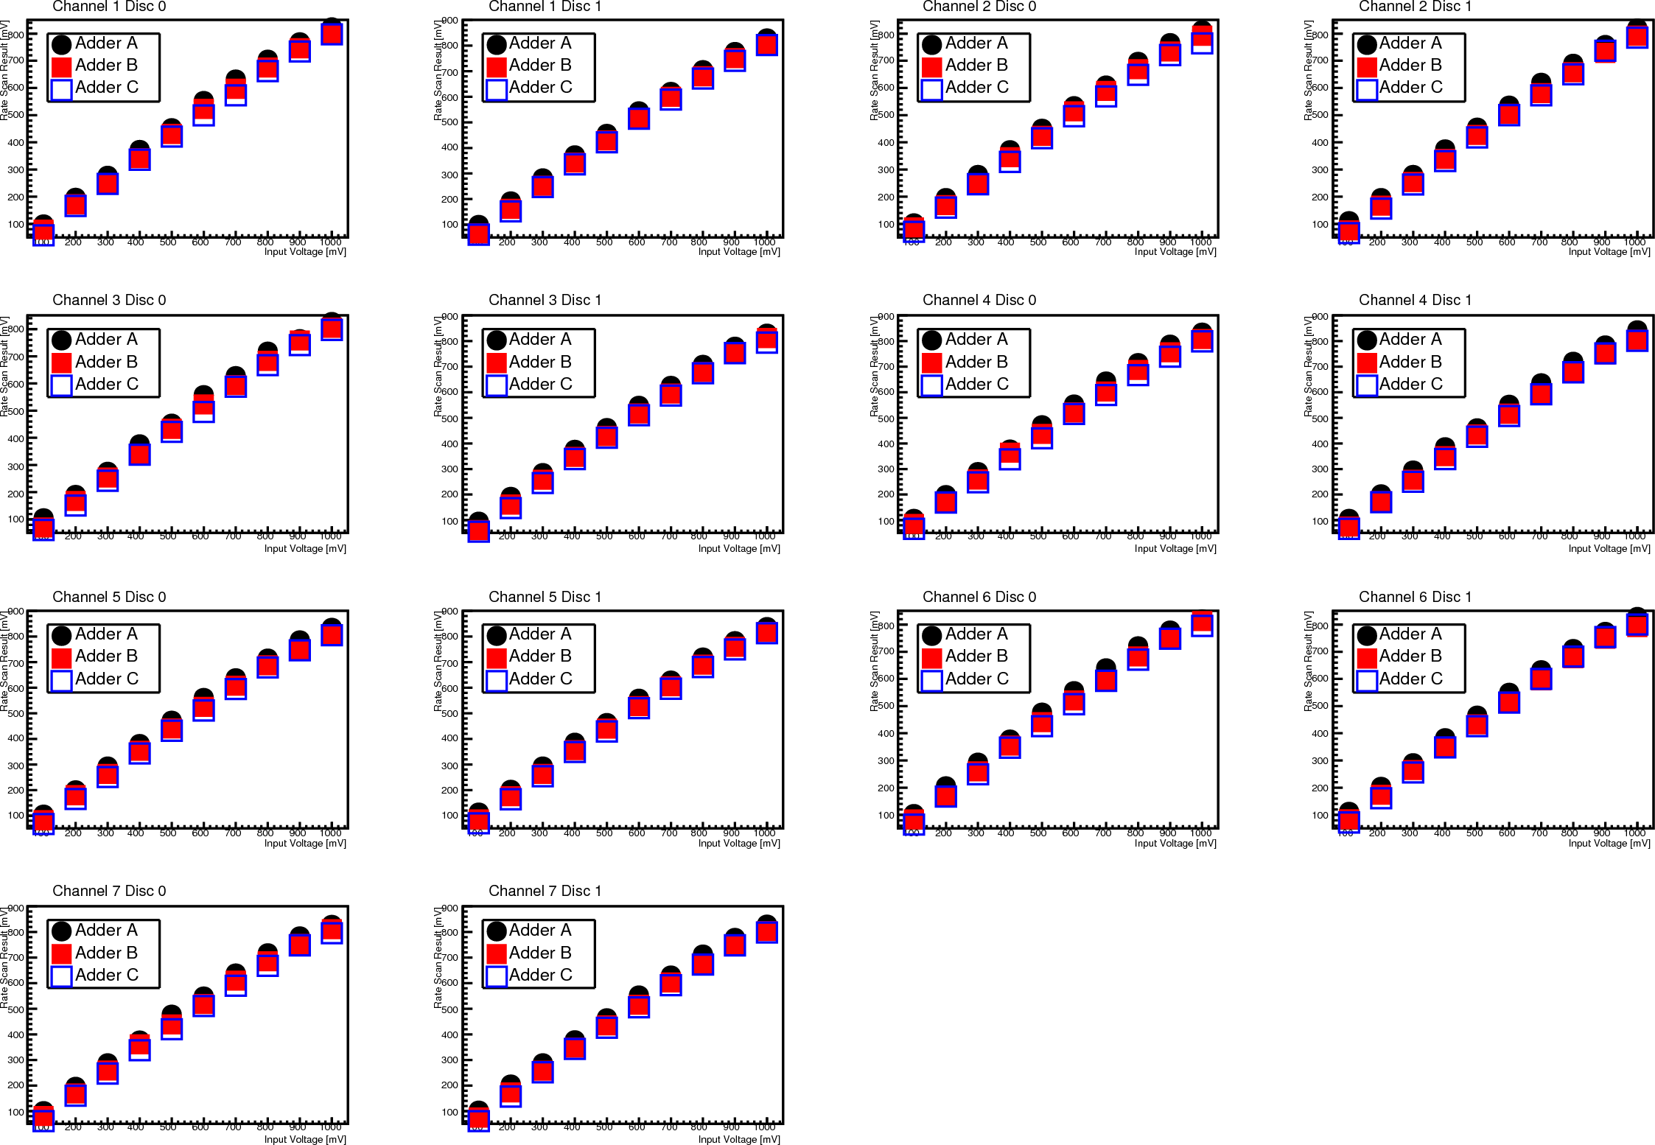Illustration 1: Data from the Test Voltage of ASIC61. Rate scan result voltage versus input voltage in mV for 3 adders, 7 channels and 2 discriminators.

From figure 1 it can be observed that the linearity is not mantained at high voltages. In order to set the best range for calculating the gain and the offset from the fit, the data have been fitted to a grade 1 polynom at different ranges (see figure 2). Then, the offset calculated from the fit is compared to the analog offset measured in the automatic test. The range where the difference is smaller must be the best for the linear fit.

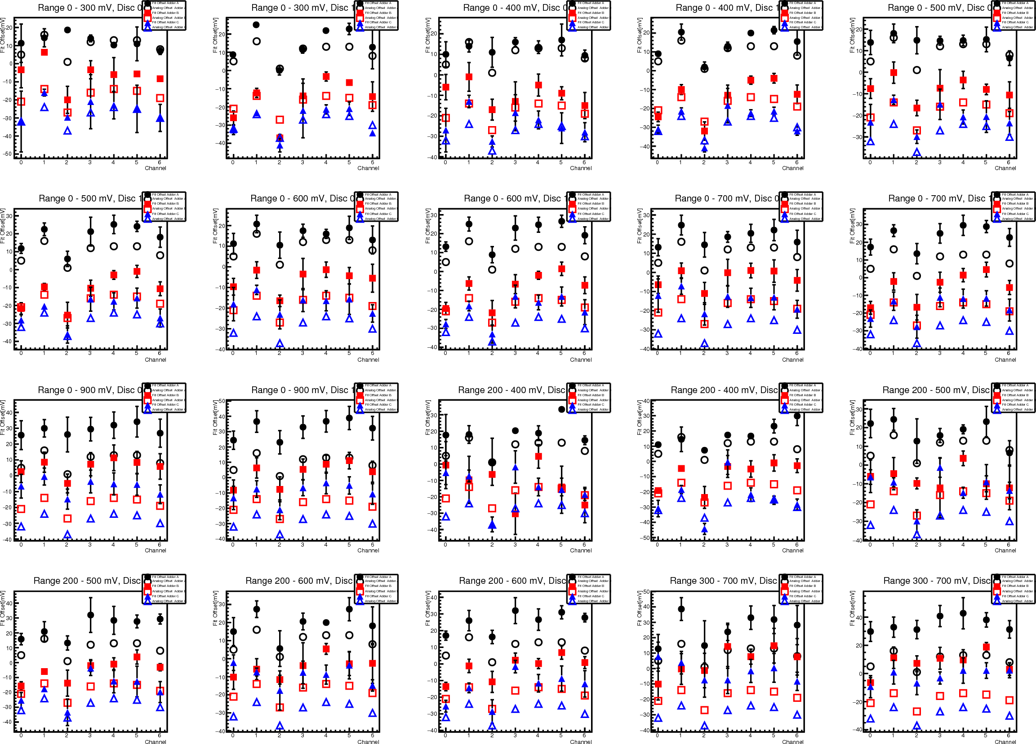Illustration 2: Offset per channel calculated from fitting the data to a grade 1 polynom at different ranges. Analog offset data is represented by filled markers. Adder A: Black dots. Adder B: Red squares. Adder C: Blue triangles.

From plots in figure 2 it can be seen that the difference between the fit offset and the analog offset increases with range, having a better matching at low voltages. For adders A and C, this behaviour ir clear from low voltages to high voltages, but Adder B doesn't seem to fit the analog offset so well at low voltages. This discrepancies at certain channels could be either a problem in the measure or in the ASIC and need to be studued.

After this analysis, the best minimun range that suits better the analog offset values is the range 0-300 mV so the Fit Offset for the rest of ASICs has been calculated at that range.
Note that possibly a lower range with more points could offer better results, but its calculation is limited by the rate scan procedure in the automatic test, which only allows steps of 100 mV.

3.2 Offset calculation for all ASICs.

Applying the method previously described, Offset from the fit of the Ratescan has been calculated for the 383 ASICs with available data and is presented as histograms for all 7 different channels, 3 adders and 2 discriminators.

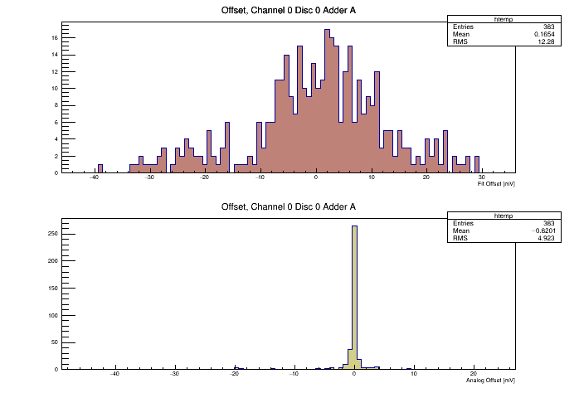Illustration 3: Fit Offset(Top) and Analog Offset(Bottom) distribution from one combination of channel, discriminator and adder, for all 383 ASICs tested.

In Appendix A there are 42 histograms in total for each offset calculated for every ASIC. It can be observed that the offset calculated has a distribution where most of the entries lays in the range from -20 mV to 20 mV having RMS in the range 12-15 and mean -4 – 4.
This is an expected result, as long as all ASICs are supposed to response in similar ways.

Correlations between offsets from different channels have been also found in order to stablish if the behaviour of the ASICs is consistent and follows a certain rule. Combinations of the Fit Offset for two different channels has been plotted for all ASICs, at a certain adder and discriminator. All possible combinations are shown in Appendix B.

From these plots we can deduce that it seems to exist a linear correlation between channels, in which when offset increases for one channel it also increases for all the others.

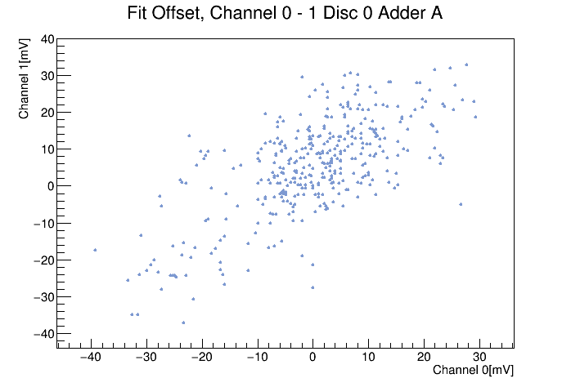Illustration 4: Fit Offset correlation between two channels, form all tested ASICs for a certain adder and discriminator.

3.2 Gain calculation for all ASICs.

In a similar way to the calculation of the offset, the gain for the ASICs has been computed from the linear fitting of the rate scan result, using the other parameter of the fit. The 42 Histograms for the gain are presented in Appendix C.

The mean for all the gains calcuated is around 0,9 mV and the RMS of the histograms is mostly in the range of 0,03-0,04.

Values of the gain seems to be much more uniform than that of the offset and it varies much less from one ASIC to another and from one channel-sum-disc combination to another within the same ASIC.

Correlation between channel has also been found for the gain and all the possible combinations of two different channels are presented in Appendix C.

In this case, correlation is not clear, all values are dispersed in a cloud around 0,9 mV and they seem to be quantized. This result could have been produced by the discrete nature of rate scan methodology.
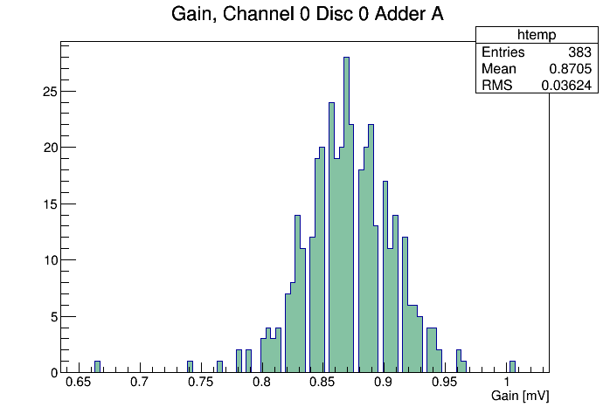Illustration 5: Gain calculated from the fit of the rate scan result from all the ASICs, for a certain combination of channel, adder and discriminator.
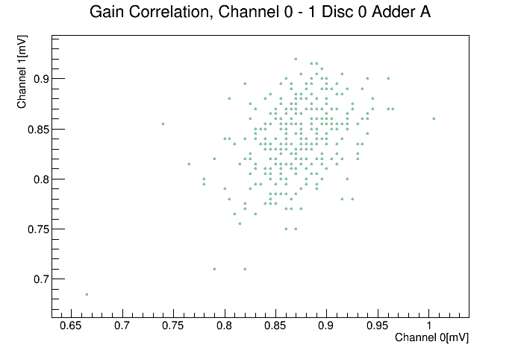Illustration 6: Gain correlation between two channels, form all tested ASICs for a certain adder and discriminator

4 Difference Analog and Fit Offset.

In order to characterize the efectiveness of calculating the offset through the fitting of the rate scan method, the differences between the Fit Offset(FO) and the Analog offset(AO) has been computed.

The distribution along all ASICs of the differences FO – AO is presented in the form of an histogram for each channel-adder-discriminator combination. It addition, it is included the distribution for FO-AO divided by the errors in the calculation of the FO, to see if it is possible to extract some information from those errors. All the 42 x 2 histograms are available at Appendix D.

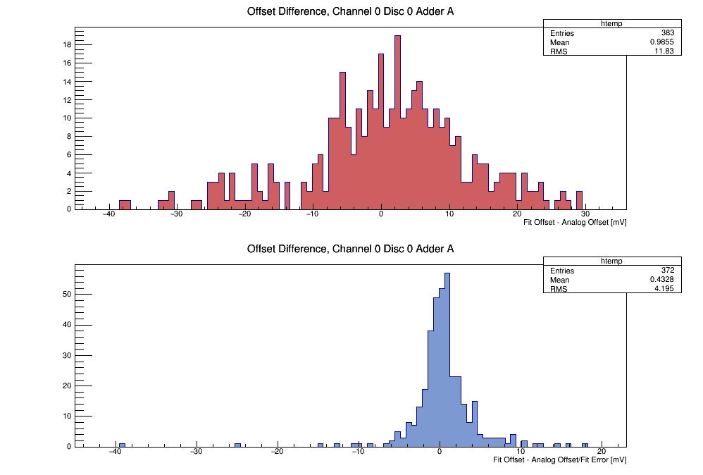Illustration 7: Difference Fit Offset - Analog Offset (Top) distribution and FO - AO/FO Error (Bottom) distribution for a certain combination of Channel, Adder and Discriminator.
Most means for FO - AO are in the range from -3 to 5 mV and in -2 to 2 mV for FO – AO/ FO Error.

The desirable result is that those differences should be the closest possible to 0 and should be no higher than 10 mV (absolute value), which is the equivalent voltage of 1 phe reaching the detector.

Correlation between channels for the difference FO-AO has also been found and the result is pretty similar to the one for the Fit Offset itself, since it seems that when the difference increases for one channel it also increases for all the others. All plots for every combination of two different channels can be found at Appendix E.

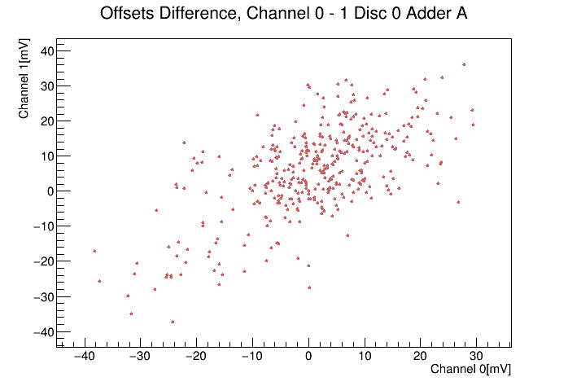Illustration 8: FO-AO correlation between two channels, form all tested ASICs for a certain adder and discriminator.

